|  |  |
| --- | --- |
| **Date** | 3 August 2025 |
| **Team ID** | LTVIP2025TMID30830 |
| **Project name** | Lease management |
| **Maximum Marks** |  |

**Problem Statement:**

Traditional lease management in property firms is often handled through **manual processes**, including spreadsheets, emails, and disconnected tools. These outdated methods result in:

* Missed deadlines for lease renewals and rent payments
* Data entry errors and duplicate property-tenant assignments
* Lack of workflow automation and approval control
* Poor communication with tenants
* No real-time visibility into lease status and performance

These challenges contribute to **reduced efficiency**, **operational risks**, and **low tenant satisfaction**, highlighting the urgent need for a modern, integrated solution.

**Solution – Salesforce-Based Lease Management System:**

To solve these challenges, a custom Salesforce Lightning App was developed to fully digitize and automate the lease management process. The solution includes:

* **📌 Custom Salesforce Objects:** Property, Tenant, Lease, and Payment – to structure and store all relevant data**.**
* **🔐 Validation Rules:** Ensure data accuracy (e.g., lease end date must be after the start date).
* **🔁 Apex Triggers:** Prevent assigning multiple tenants to a single property.
* **📨 Email Templates & Scheduled Jobs:** Automate rent reminders, approval notifications, and payment confirmations**.**
* **👤 Approval Workflows**: Handle lease request approvals and rejections through automated flows.

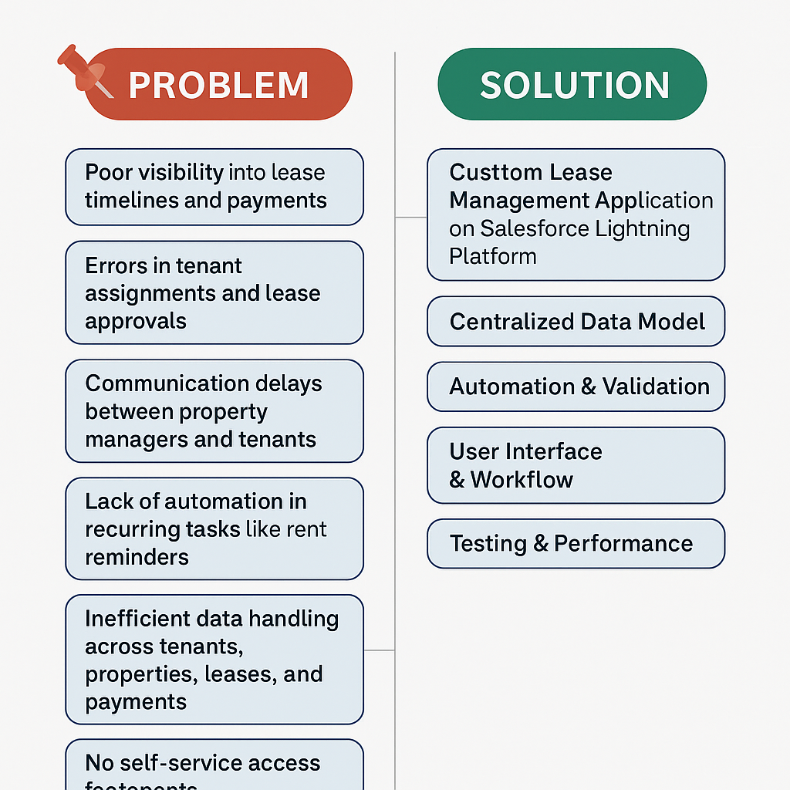

**This solution results in:**

* Reduced manual effort and errors
* Faster processing and communication
* Improved visibility and control
* A scalable system ready for future enhancements like payment integration and tenant portals

**CONCLUTION:**

The Lease Management Project effectively addresses the critical issues faced in traditional lease handling by delivering a **centralized, automated, and intelligent system** built on the Salesforce platform. It solves key challenges such as manual data entry, missed deadlines, inconsistent communication, and lack of real-time tracking.